Measurement Utility Instructions and Readme

Application Developed by Elijah Kerry, CLA – National Instruments

Measurement Utility

3.0 Beta Version

November 20th, 2013

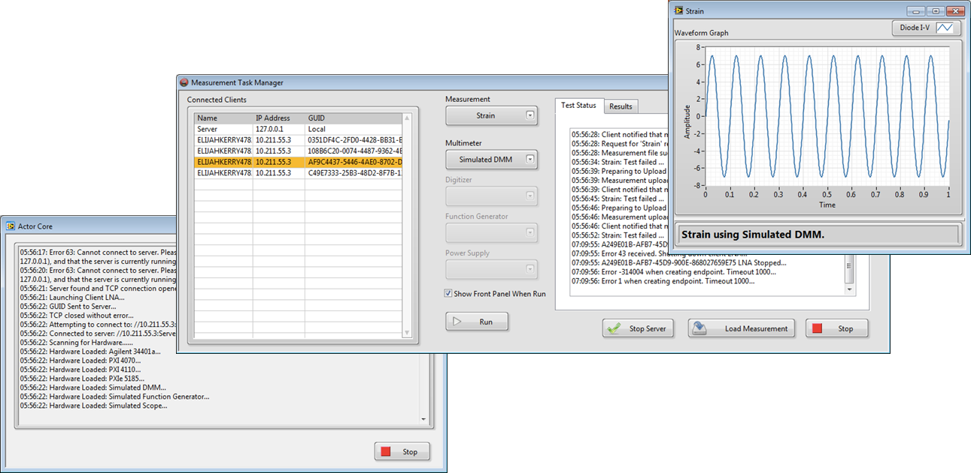

Figure 1: This shows the server with five locally connected clients (only 1 client shown)

Contents

System Overview 2

New Features in 3.0 2

What’s In the Project 2

Launching the System in the Development Environment 3

Launching the Systems in the Run-Time Engine 4

Running a Measurement System 5

High-Level Sequence Diagram of System Operation 7

Detailed Sequence Diagram of Network Connection 8

Creating a New Measurement 9

Changing Controller Configurations 9

Running the Clients Remotely 9

Remaining Work Prior to Release Version 10

Future Features 10

# System Overview

The Measurement Utility is a framework that dynamically loads measurement definitions and hardware device plugins at run-time. The framework presents a user interface that allows a user to execute measurements using the hardware that is available and aggregates and displays the results returned by each measurement.

This system was written to explore common architectural challenges when building large measurement systems, including:

* Definition of abstraction layers for hardware and for measurements
* Creation and distribution of templates to enable team-based development
* Use of the Actor Framework for a large multi-process system
* Definition of build specifications for plugins to be loaded by an executable
* Compartmentalizing development into multiple libraries and projects
* Networked communication across multiple systems

The server is a complete stand-alone measurement system. You do not need to launch clients to use it, as it is capable of loading measurement and hardware plugins and executing measurements. However, the default behavior in this version only has Measurements loaded by the server and Hardware plugins are loaded by clients when they connect (this was done to illustrate a likely usage scenario and how they communicate with each other). This behavior can be altered by modifying the configuration file for the server, which specifies where hardware devices should be loaded from.

# New Features in 3.0

* Ability to network multiple client controllers, which are run and sequenced by the server controller.
* Ability to load and push new measurement strategy from server to clients at run-time
* General re-organization of code to improve scalability

# What’s In the Project

* The Measurement System project that is created from the ‘Create Project’ dialog aggregates multiple items that would normally be distributed as separate projects. This was done to make it easier to open-and-run the code. Included components that should be managed in unique projects include:
  1. The server controller
  2. The client controller
  3. Sample Measurements
  4. Sample Hardware

# Launching the System in the Development Environment

1. Launch the server:

* Expand the ‘Server’ virtual folder
* Expand the ‘Server Controller.lvlib’ library
* Expand the ‘Server Controller.lvclass’ class
* Open and run ‘main.vi’ (see Figure 2)

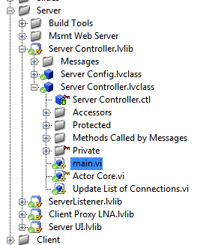

1. Launch client(s)

* Expand the ‘client’ virtual folder
* Expand the ‘Client Controller.lvlib’ library
* Expand the ‘Client Controller.lvclass’ class
* Open and run ‘main.vi’

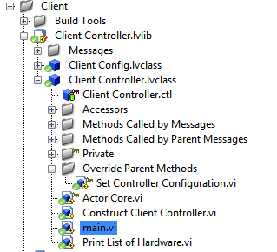

# Launching the Systems in the Run-Time Engine

Once built, the executables will need to be told where to load the plugins from – you cannot just point to the plugins in their source directory, as the run-time engine will not be able to find dependencies from drives and vi.lib. You will need to open the projects for the respective plugins and run their build specifications.

1. Run all of the included build specifications for the framework, which should include

* Server Executable
* Client Executable
* Client Executable FOR TESTING ONLY

To do this, right click on ‘Build Specifications’ and select ‘Build All’

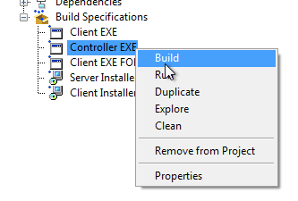

Run both the client and server executables. The client can be run on a remote system.

1. To create the deployed version of the plugins, open the projects that are included under the ‘Sample Measurements’ and ‘Sample Hardware’ virtual folders:

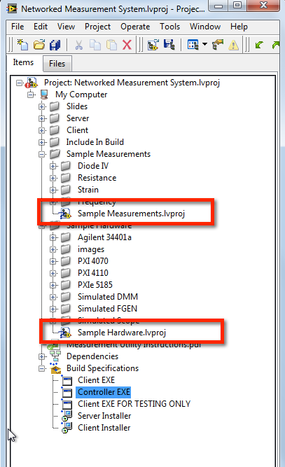

1. Once open, expand the pre-configured build specifications. Run the source distributions first, then the installers. Running the installer will move the deployed versions of these plugins into the C:\ProgramData\Measurements and C:\ProgramData\Hardware folder respectively. The default settings of an executable will search these locations, so they can be launched and should load these without additional configuration.

# Running a Measurement System

1. Once the server controller and client are running, click ‘Start Server’ on the Server’s user interface. This will launch the TCP listener that will connect all running clients on the same subnet. Once connected, the client will scan for locally available hardware

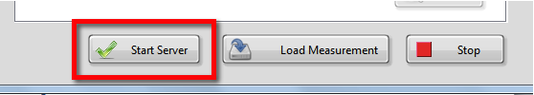

1. A list of active connections should appear in a new listbox on the left

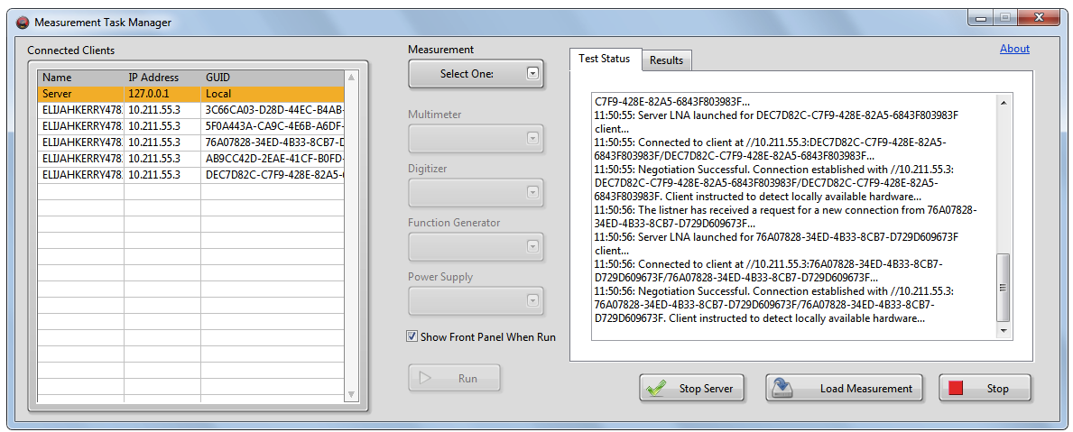

1. Highlight the client where you want to run a measurement
2. Select the measurement you want to run from the drop-down
3. Select the devices you want the client to use
4. Click ‘Run.’ The Client will receive a command to run a measurement, download the measurement (if necessary), and run it locally. Once complete, it will return the results to the server.

# High-Level Sequence Diagram of System Operation

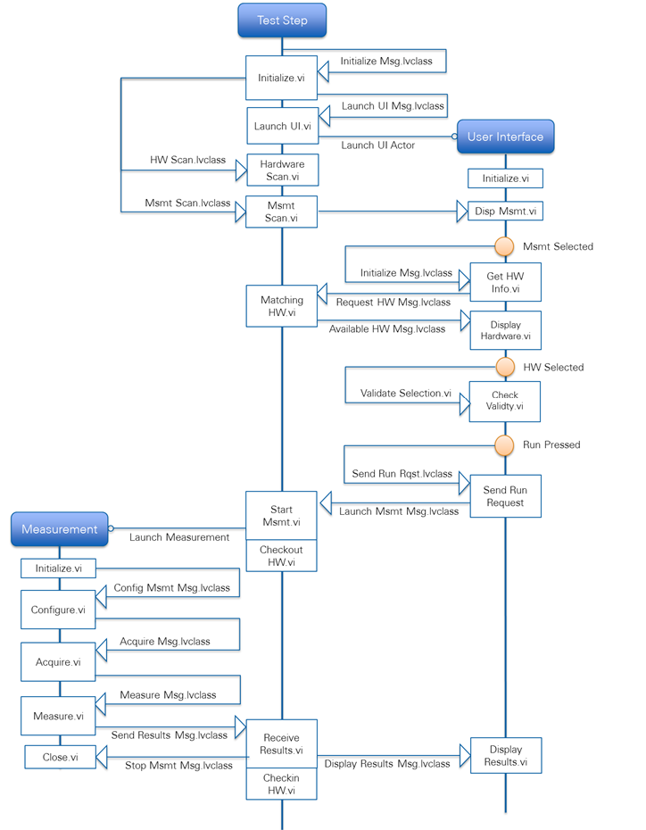

# Detailed Sequence Diagram of Network Connection

The following diagram illustrates how the server and client connect. The powerpoint slide where this diagram was created is included in the project

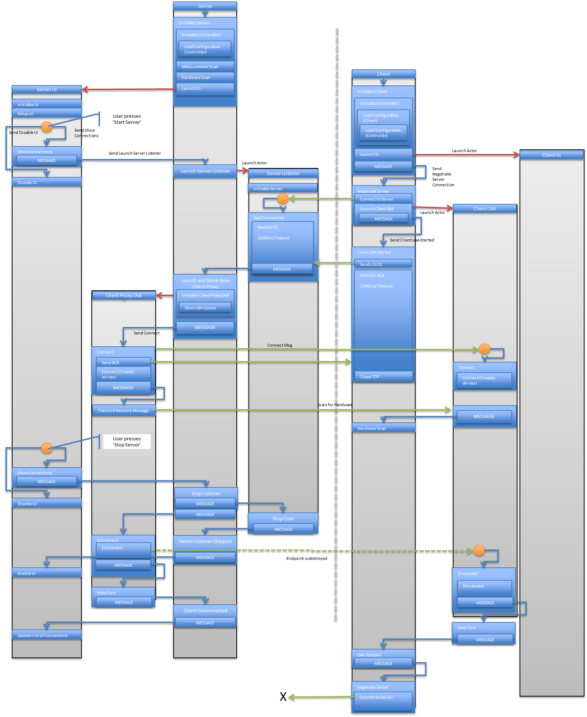

# Creating a New Measurement

Return to the ‘Create Project’ dialog and click on ‘New Measurement.’

This template is designed to make adding a new measurement to the system simple and easy. Select the types of devices this measurement will need to use along with the methods you want to customize. The project that is created includes the stub VIs along with preconfigured build specifications

# Changing Controller Configurations

Both the server and client controllers load configuration and preferences from an INI file. This file is human readable and can be modified in a text-editor. However, it can also be modified within the software by clicking ‘Settings’ for either the server or client. From this dialog, a user can configure which paths to search for measurements and hardware. Paths can be relative to the location of the ini file, they may point to a directory, or they may point directly to a lvclass file.

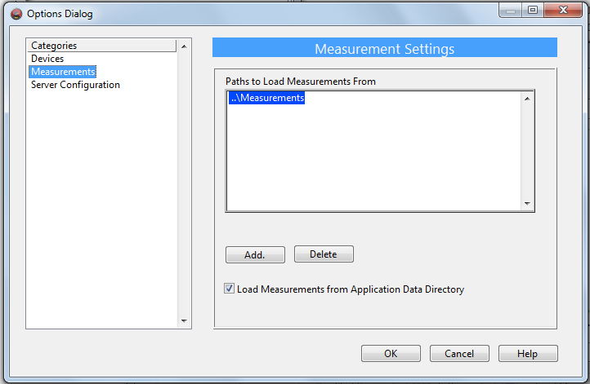

# Running the Clients Remotely

The IP address of the server needs to be known to the clients in order to initiate the connection. This currently can only be configured from the INI file for a client.

# Remaining Work Prior to Release Version

This application is considered feature complete. Remaining works includes testing and validation of code, as well as additional block diagram documentation. Please send any feedback or problems you encounter to Elijah.Kerry@ni.com

# Future Features

* Inclusion of Hardware device template.
* Auto-generation of configuration file
* Results should include information about which client they were executed on
* The log should be exportable or auto-saved to disk
* The IP of the server should be configurable from client UI